**Module (CSS and CSS 3) -2**

1. **What are the benefits of using CSS?**

**Ans.** Below are some more benefits that you would want to consider:

* By employing CSS, you can create one style sheet for all the web pages. So, if you need to modify the entire website, you only need to change that one sheet.
* CSS helps you to organize codes as per your choice. You can add the most valuable and keyword-oriented content on the top and shift the less important below the main content. Thus, you can increase your website ranking in search engines.
* It enables you to make your website compatible with a wide range of devices.

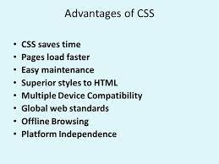

1. **What are the disadvantages of CSS?**

* **Ans.** It is unable to send requests to an internet page.
* Almost zero capability to act with the database.
* It lacks in security considerations.
* There are different versions of CSS (e.g., CSS1, CSS2, CSS3, etc.) that creates some confusions.
* Browser association drawback. CSS written in one browser might not work properly in others.

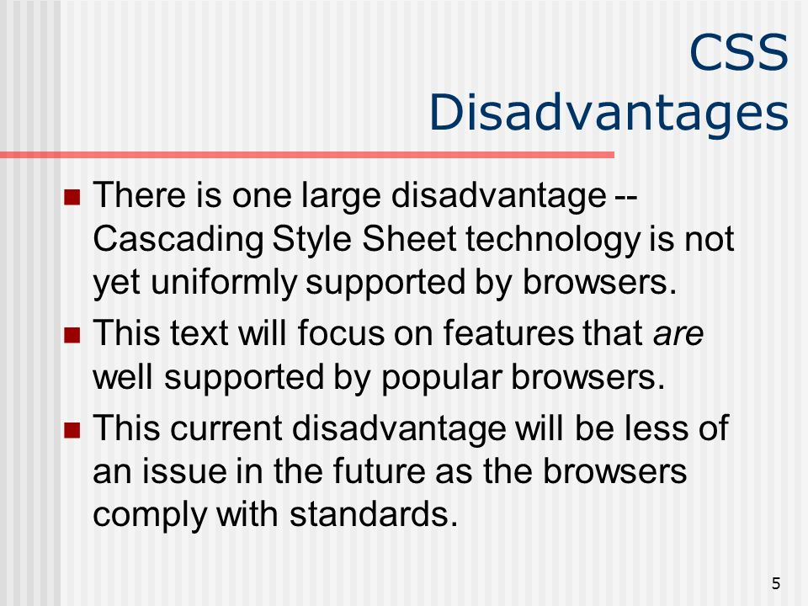

1. What is the difference between CSS2 and CSS3?

**Ans.**

* CSS3 is split into many various documents known as Modules. each module adds new capability or extends options outlined in CSS2 over conserving backward compatibility. Work on CSS3 started around the time of publication of the initial CSS2 recommendation.
* The CSS3 version supports more browsers than CSS2.
* New values and new units square measure introduced to support all those new properties. for example, Angle units deg, grad, rad, and switch or Time units s and ms.
* The new addition of General relation Combinator will be wont to match relation parts of a given part through diacritic (~) combinator.

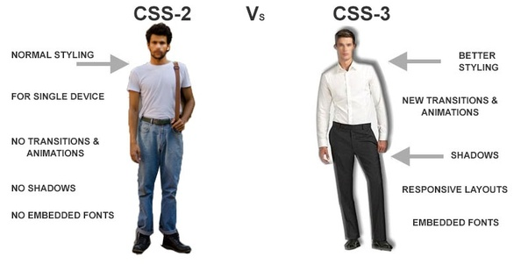

1. **Name a few CSS style components.**

**Ans.** **Selector:** class name, id name or element name that is target  
**Attribute:** name of the attribute you want to style for example border, color, background, position etc.  
**Value of Property:** value that will be assigned to attribute.

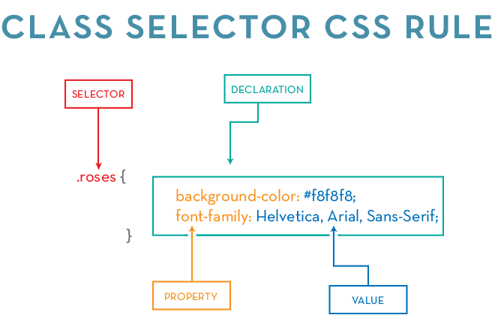

1. **What do you understand by CSS opacity?**

**Ans.** The opacity CSS property sets the opacity of an element. Opacity is the degree to which content behind an element is hidden, and is the opposite of transparency.

1. **How can the background color of an element be changed?**

**Ans.** You can change the background color of an HTML element using the background-color CSS property and giving it a value of a color.

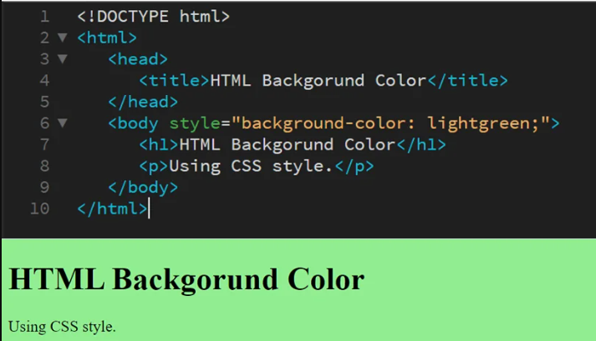

1. **How can image repetition of the backup be controlled?**

**Ans.** To control the repetition of an image in the background, the CSS background-repeat property is used. For no repeat use no-repeat and for repeat use repeat property.

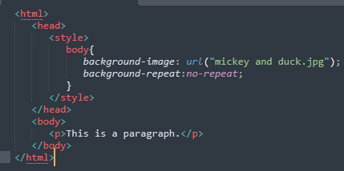

1. **What is the use of the background-position property?**

**Ans.** The CSS background-position property allows us to specify a position for a background image within an element.

You can use a combination of position keywords: center, top, bottom, left and right.

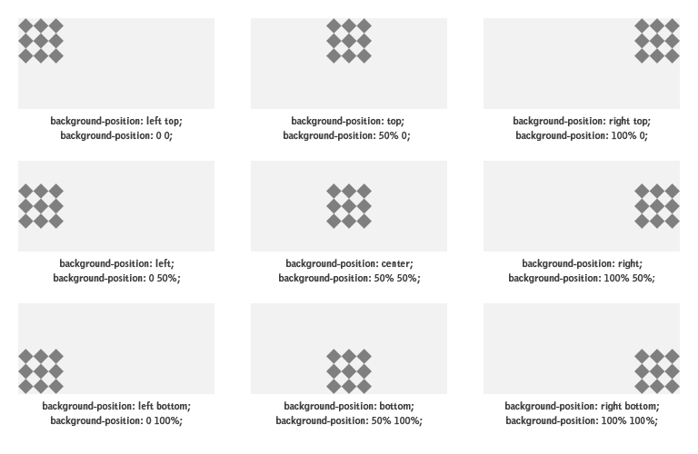

1. **Which property controls the image scroll in the background?**

**Ans.** CSS background-attachment property controls whether the background image scrolls or remains fixed with the page's content.

Background-attachment property

* Scroll : allows the background image to scroll with the page (default value).
* Fixed :stops the background image from scrolling with the page.
* Local : allows the background image to scroll with the element's content.
* Initial : sets the property value to default.
* Inherit :  inherits the property value from its parent element.

For example,

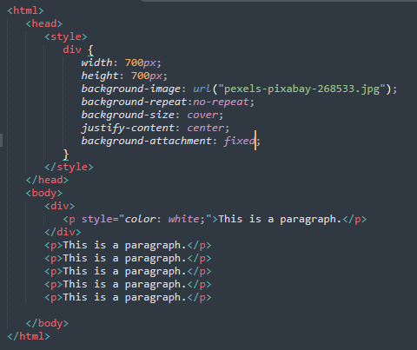

**10) Why should background and color be used as separate properties?**

**Ans.** In web development and design, using background and color as separate properties allows for more flexibility and control over the appearance of elements on a webpage.

separating background and color properties in web development provides greater control, versatility, maintainability, accessibility, performance optimization, and adaptability, ultimately contributing to a better user experience and a more efficient development process.

**11) How to center block elements using CSS1?**

**Ans.** To centrally align the block elements, we can simply make use of the <center> tag. All the elements within the <center> tag will be centrally aligned. Also we can center block element

With css the way to center anything that’s a block level element is with the margin property. One of the values of margin is auto and by setting auto on the left and right margin our block

level element will center itself.

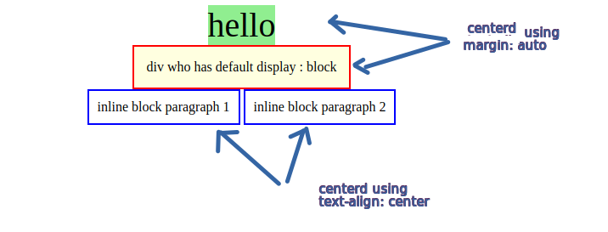

**12) How to maintain the CSS specifications?**

**Ans.** Here is some specification for maintaining css.

**1-Consistent Indentation and Formatting:** Maintain consistent indentation and formatting throughout your CSS files. Use spaces or tabs consistently for indentation, and choose a formatting style that is easy to read and understand.

**2-Comments and Documentation:** Include comments to explain the purpose of different sections or rules in your CSS. Document complex or important styles, especially those that may not be immediately obvious to others.

**3-Use Meaningful Class and ID Names:** Choose clear and descriptive names for classes and IDs that reflect the purpose or function of the elements they style. Avoid generic or cryptic names.

**4-Modularize Your CSS:** Organize your CSS into separate files or modules based on functionality or components. This makes it easier to manage and maintain the styles, especially in larger projects.

**13)** **What are the ways to integrate CSS as a web page?**

**Ans.** There are 3 ways to integrate CSS

**Inline Styles:** Inline styles are added directly to HTML elements using the style attribute.

**Internal Styles**: Internal styles are defined within the <style> element in the HTML <head> section.

**External Stylesheet Link:** The most common method is linking an external CSS file using the <link> element in the <head> section. This allows you to separate CSS from HTML, facilitating better organization and reusability.

**14) What are embedded style sheets?**

**Ans.** Embedded style sheets, also known as internal styles or embedded styles, involve placing CSS styles directly within the HTML file. This is achieved by using the **<style>** element in the HTML **<head>** section to define styles for the document.

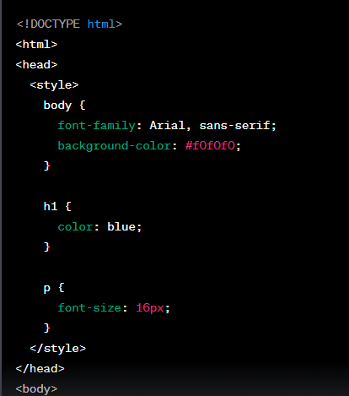

**15) What are the external style sheets?**

**Ans.** External style sheets refer to separate CSS files that are linked to an HTML document using the <link> element. These CSS files contain styles and formatting rules that are applied to HTML elements across multiple pages of a website. External style sheets promote the separation of content (HTML) from presentation (CSS), a fundamental principle of web development.

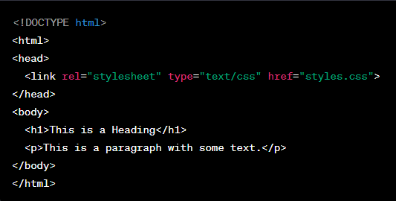

**16) What are the advantages and disadvantages of using external style sheets?**

**Ans.**

**Advantages:**

The main advantage of external styling is that, when it is linked to by every page, it ensures all pages are uniform in look and style creating a cohesive website. It also allows you to focus on the other aspects of web design when creating the other pages as you don’t need to worry about the styling as that is already done thanks to the external file. Additionally, it keeps your other pages code nice and tidy as all the styling, which can often entail a lot of code, is separated onto a completely different file.

**Disadvantages:**

The main disadvantage of external CSS is that it does not allow for more specific controlling of certain elements so, if you were to only use external styling, every single version of the same element would look exactly the same. To combat this, you could use internal styling, in-line styling or both in addition to external. Additionally, the CSS file must be referenced by every page of the site, if it is not, none of the formatting it sets out will be applied.

**17) What is the meaning of the CSS selector?**

**Ans.**

A CSS (Cascading Style Sheets) selector is a pattern or expression that identifies HTML elements to which styles will be applied. Selectors target specific elements based on their HTML tag, class, ID, attributes, or their relationship with other elements in the HTML structure.

Here are common types of CSS selectors:

**Element Selector:**

Targets HTML elements based on their tag name. For example, to target all <p> elements: p { ... }.

**Class Selector:**

Targets HTML elements with a specific class attribute. For example, to target elements with the class "my-class": .my-class { ... }.

**ID Selector:**

Targets a specific HTML element with a unique ID attribute. For example, to target an element with the ID "my-id": #my-id { ... }.

**Attribute Selector:**

Targets HTML elements with a specific attribute or attribute value. For example, to target elements with a "href" attribute: [href] { ... }.

**Descendant Selector:**

Targets elements that are descendants of a specific element. For example, to target <a> elements within a <div>: div a { ... }.

**Child Selector:**

Targets elements that are direct children of a specific element. For example, to target <p> elements that are direct children of <div>: div > p { ... }.

**Pseudo-class Selector:**

Targets elements based on their state or position. For example, :hover targets an element when it's being hovered over by the mouse.

**Pseudo-element Selector:**

Targets a part of an element (e.g., first line, first letter) or generates content. For example, :: first-line targets the first line of a block-level element.

**Grouping Selector:**

Groups multiple selectors together to apply the same styles to all of them. For example, h1, h2, h3 {...} targets <h1>, <h2>, and <h3> elements.

**18)** **What are the media types allowed by CSS?**

**Ans.** CSS supports different media types, allowing styles to be applied based on the characteristics of the output device or medium. Media types enable the design and presentation of web content to be adapted for various devices such as screens, printers, speech-based browsers, and more.

Example:

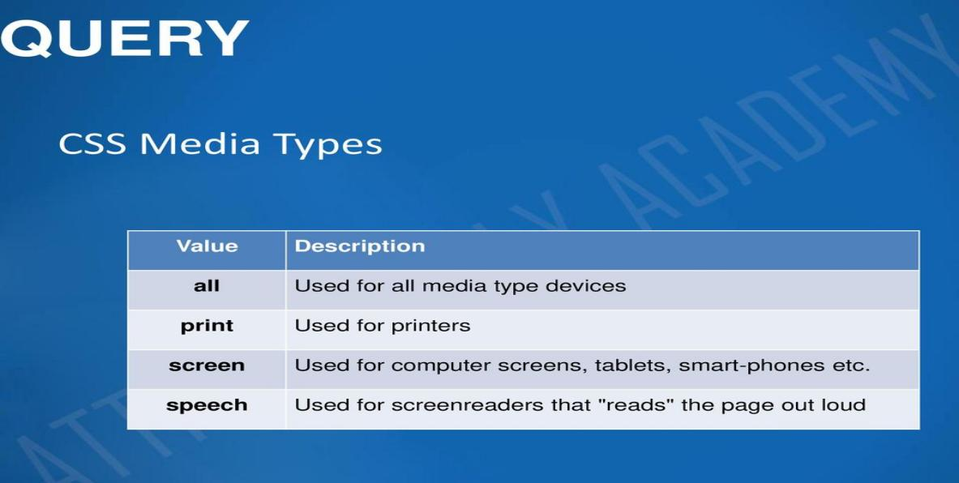

**19) What is the rule set?**

**Ans.**  A rule set is a fundamental structure used to define styles for HTML elements. It consists of a selector and a declaration block.

**Explanation of the components:**

**Selector:** The HTML element or elements to which the styles will be applied. It can be a tag name (e.g., p), a class (e.g., .my-class), an ID (e.g., #my-id), or any other valid selector.

**Declaration Block:** A set of CSS properties and their corresponding values enclosed within curly braces {}. Each property-value pair is separated by a colon (:), and each declaration ends with a semicolon (;).

**20) Create Layouts**

**Ans.**  <https://github.com/Kp9056/CSS-Task-layout>

**Pending Question from HTML Assignment**

* **How are active links different from normal links?**

**Ans:**

1. **Normal Link:** A normal link is a standard hyperlink that is typically styled and formatted to stand out from the rest of the content on a webpage. When a user clicks on a normal link, they are redirected to another webpage or resource.
2. **Active Link:** An active link is a term that's sometimes used to describe a link that is currently being interacted with or is in a state where it can be clicked. For example, when you hover your mouse pointer over a link and it changes colour or appearance, indicating that it's active or ready to be clicked, it's often referred to as an active link.